University of Miskolc
Faculty of Mechanical Engineering and Informatics

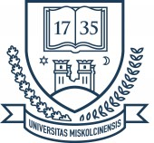

title of the thesis

Booklet of PhD Theses

Prepared by:
NAME

István Sályi Doctoral School
Topic Field of Engineering Material Science, Production Systems and Processes
Topic Group of Materials Engineering and Mechanical Technology

Head of Doctoral School

Head of Topic Group

Scientific Supervisor

Miskolc
2021

Judging Committee

chair:

secretary:

members:

Official Reviewers

- introduction

- NEW scientific results – theses
- The

- The

- The

- The

- The

- The
- LIST OF PUBLICATIONS RELATED TO THE TOPIC OF THE RESEARCH FIELD
- H. X.
- literature cited in the theses booklet
- EN

