Zotero workshop: Simplify your reference management!


To improve the soft skills for the Ph.D., István Sályi Doctoral School in Mechanical Engineering Sciences would like to welcome you to join the online Workshop about ZOTERO, organized:
on Tuesday, 15 December 2020, from 2 pm to 5 pm.
The purpose of the Workshop is to make the participants able to use ZOTERO; thus, it is required for all the participants to install Zotero.
Professor Aniss MOUMEN will moderate the Workshop.
To install Zotero and its Extension, please follow the steps' details on Page 2 and 3.
You can join the Workshop using the Zoom platform using the link below.
The Zoom link: https://zoom.us/j/96129491456?pwd=ZGRWVEN4NTUxSm94VWVaYjlMRUJsQT09

Meeting ID: 961 2949 1456
Passcode: 500761

Guideline to Install ZOTERO
Before Installing ZOTERO, DON'T FORGET TO CLOSE ALL THE MICROSOFT OFFICE LOGICIELS SUCH AS MICOROST WORD, EXCEL, POWERPOINT, ETC…
1- To install, go to http://www.zotero.org/ and click the red "Download" button.
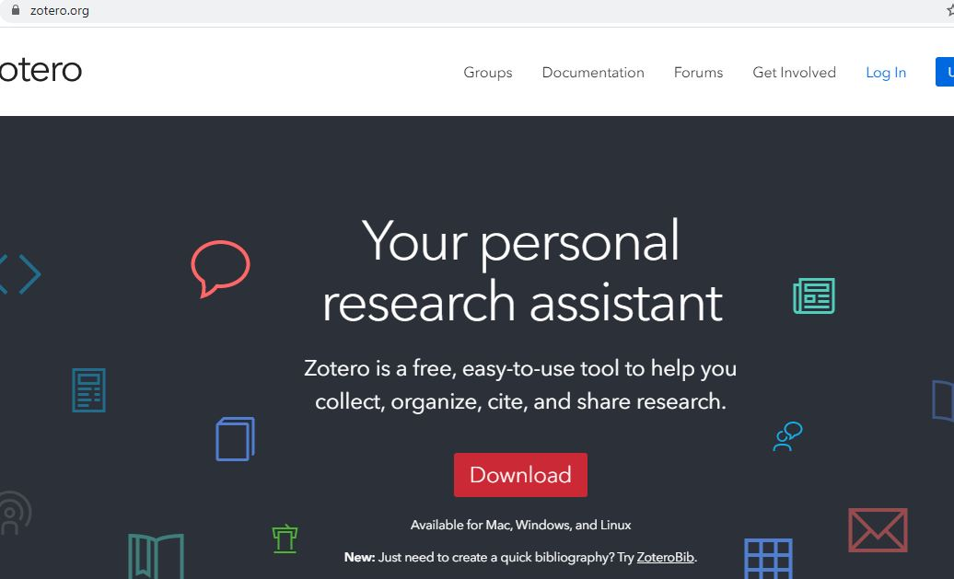
2- Click "Download" ZOTERO 5.0 for Windows; you can choose ZOTERO for Linux if you are not using Windows
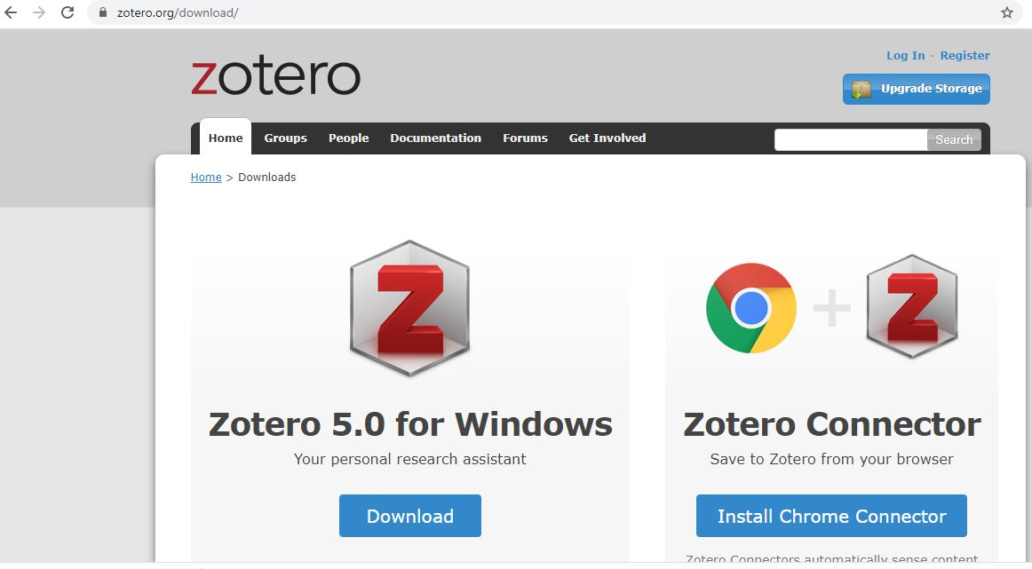
3- After downloading ZOTERO, install it; the process will take around 2 to 3
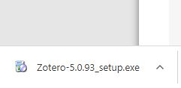

After Installing ZOTERO, The next step is to install ZOTERO EXTENTION
4- Go to the same page from where you downloaded ZOTERO 5.0, and this time click on "Install Chrome connector."
5-Click "Add Extension."
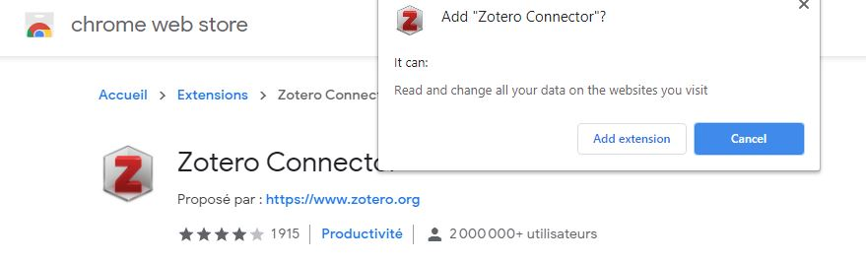


The Extension of ZOTERO connector should appear like this

NOW THE INSTALLING PROCESS IS DONE, AND YOU READY FOR THE WORKSHOP

