Content, form and formal requirements for the thesis or diploma project

The thesis/diploma project is the first work that demonstrates the ability to independently and consistently apply what has been learned during the training. In addition to the content, however, it must also meet specific form and formal requirements, reflecting the precision and regularity essential in engineering work.

The thesis/diploma project must be submitted in a word-edited format, in one copy, with a hardcover cover, in such a way that subsequent modifications (e.g. inserting new pages, replacing parts, etc.) are not possible. For this reason, spiral binding or staple binding are not permitted.

Font: Times New Roman.
Font sizes: chapter titles 14 points, text 12 points, any notes or footnotes 10 points.
Line spacing: 1.5.
Margin: left 3 cm, all other 2.5 cm.
The thesis/diploma project should consist of main chapters, sections, subsections and periods. Their numbering (or designation):
chapter 1., 2., …, i;
section 1.1., 2.1., …, i.j;
subsection 1.1.1., 2.1.1., …, i.jk;
If necessary, further division can be applied in the so-called decimal system. When numbering, except for the main chapters, groups of three should be formed (e.g. 1.126.521), which should be separated by a period. The titles of the main chapters should be placed in the center, all other titles on the left.
Each main chapter should be on a new page. Main chapters, sections, subsections, etc. should be clearly separated from the rest of the text (e.g. by changing the font size, using bold or italics, etc.), and one line should be left blank before and after them.
Formulas should be placed indented (preferably 3 cm from the edge of the line, or aligned in the middle), and each should be numbered in parentheses at the end of the line. When using them, the basic relationship must first be indicated (letters for physical quantities) using symbols in accordance with the requirements of the MSZ 4900 standard series. Replacing them with Anglo-Saxon type acronyms is not permitted!
The basic relationship should be followed by the substitution – numerical value and unit of measurement – ​​and then the final result. Intermediate steps – apart from derivations – should not be indicated.
The letter symbols of physical quantities should be clearly distinguished from the text (e.g. bold or italic), and their interpretation should be given after the relationship (before it if justified).
Figures should be placed in the center, with a figure number, figure caption and possibly a reference. For example:
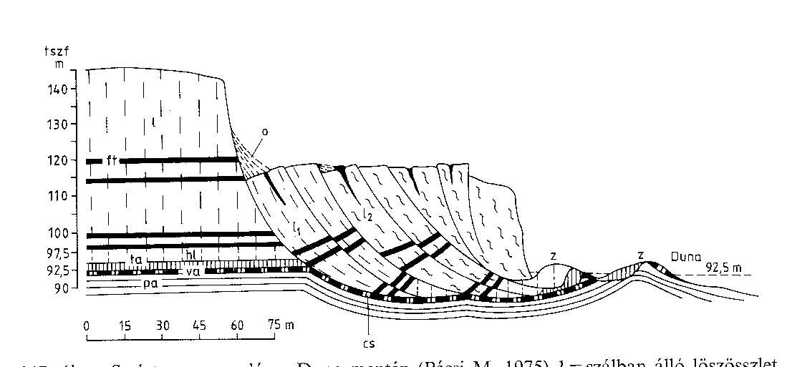
Fig. 12. Stand [35]

Only one side of the page may be used, and all pages, except the title page, must have a framed header, with the title of the thesis/diploma project on the left, the page number in the middle, and the title of the main chapter on the right.
References to literature (source works) should be placed in square brackets, referring to the detailed data provided in the bibliography for identification purposes.

The structure of the thesis/diploma project should be as follows:

Front page
Thesis/diploma project assignment statement 1. page,
Thesis/diploma project assignment statement 2. page,
Declaration of authenticity
Table of contents begins on page 5,
{Table of contents}
Introduction
Chapters (broken down into main chapters, subchapters, etc.)
Summary
References
Appendix (attachments)
Drawing documentation.

The table of contents should list each separate section.

The notation list contains all notations that appear in the thesis/diploma project. These should be listed in alphabetical order, indicating the symbol used, then the unit of measurement, and finally its name. First, the Latin letters should be listed, then the Greek letters, and finally the subscripts and superscripts.

The introduction is essentially a more detailed formulation of the objective, a description of the solution method, and a brief reference to the measurements and experiments performed, in accordance with the thesis/diploma project assignment statement. It is essential to mention the most important literature used and the method used to arrive at this conclusion. It should not exceed one page in length.

The substantive part of the thesis/diploma project is the discussion divided into main chapters, sections, etc. Since the thesis is the candidate's first engineering work, which is intended to demonstrate a certain degree of independence and the ability to uniformly apply the knowledge acquired during college studies, it must therefore reflect this. The same applies for the diploma project as well. Accordingly, "work" that consists of "scissoring together" or expediently grouping technical literature or factory brochures, operating instructions, etc. and does not indicate independent activity cannot be accepted. Of course, such details may occur in justified cases, but the source must always be given precisely. The thesis/diploma project does not have to contain new knowledge, but it must prove the candidate's suitability for the chosen profession.
You must be able to apply and utilize the literature. You must rely on their material and solve the task accordingly.
The structure of the thesis/diploma project should be clear, the style clear, and the wording unambiguous. Pay attention to spelling and checking the completed text!

The substantive work performed, highlighting the most important results, is included in the summary. Its length should preferably not exceed one page.

The length of the entire thesis should be at least 40 and at most 60 pages. The length of the entire diploma project should be at least 60 pages long and no more than 100 pages long.

The bibliography should contain all the information necessary to clearly identify the source works used. The following should be provided when citing:
- in the case of books: author (without academic degree, e.g. dr.), title of work, publisher, place of publication, year of publication, page number. E.g.:
[1] Farkas J.: Fémszerkezetek Tankönyvkiadó, Budapest, 1974. 1/345 p.
- in the case of journal articles: author, article title, journal name, journal publication place, volume, year, issue number, page number. E.g.:
[15] Cselényi J.: Lemezből hegesztett, hajlított és nyírt I-tartók optimális méretezése. =GÉP (Budapest). 16(1966)9. p. 354/349.
- In the case of brochures: title, manufacturer, place of publication, year of publication, page number

Departments may also impose additional requirements regarding the preparation of the thesis/diploma project, depending on the specifics of the task.

To defend your thesis/diploma project, you must prepare a presentation containing 5-8 slides or PowerPoint pages. These may be supplemented with a few additional slides based on the evaluation.

